**Inexpensive Vacations - District of Columbia**

Inexpensive Vacations - District of Columbia Jun 17, 2016

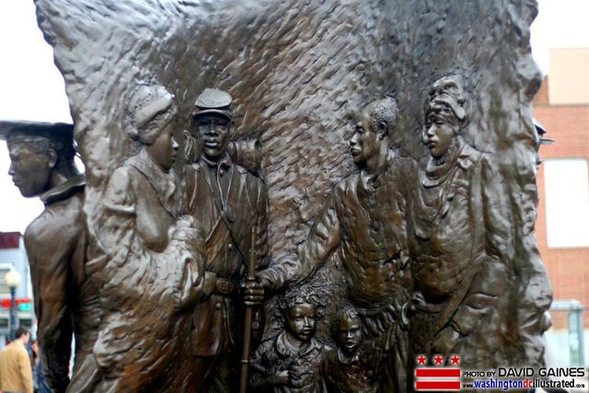

1. African American Civil War Memorial

Washington, DC Over 200,000 African-American soldiers and sailors served in the U.S. Army and Navy during the Civil War. Their service helped to end the war and free over four million slaves. The African American Civil War Memorial honors their service and sacrifice. Also, look on the Mall for the new African American History museum that is under construction. (Source: U S National Park Service)

Read more: [http://www.mycouponbuddy.com#ixzz4F0jcjROU](http://www.mycouponbuddy.com/#ixzz4F0jcjROU)

Inexpensive Vacations - District of Columbia Jun 17, 2016

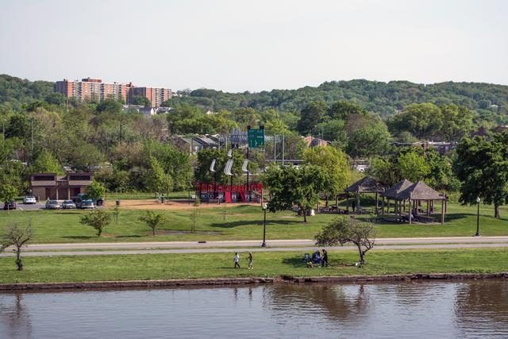

2. Anacostia Park

Washington, DC Whether you exercise along the river trail or relax by the water, Anacostia Park is a breath of fresh air and a space to unwind amid a bustling city. (Source: U S National Park Service)

Read more: [http://www.mycouponbuddy.com#ixzz4F0jfS9Fi](http://www.mycouponbuddy.com/#ixzz4F0jfS9Fi)

## Inexpensive Vacations - District of Columbia Jun 17, 2016

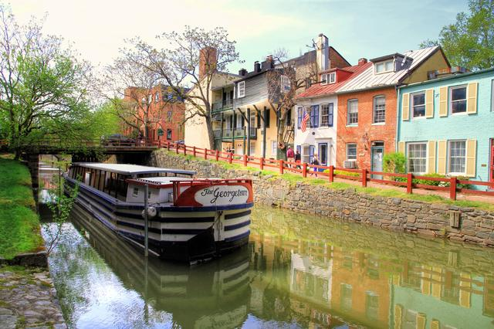

3. Chesapeake & Ohio Canal National Historical Park

Potomac River, DC,MD,WV Preserving America's early transportation history, the C&O Canal began as a dream of passage to Western wealth. Operating for nearly 100 years the canal was a lifeline for communities along the Potomac River as coal, lumber, and agricultural products floated down the waterway to market. Today it endures as a pathway for discovering historical, natural and recreational treasures! (Source: U S National Park Service)

Read more: [http://www.mycouponbuddy.com#ixzz4F0jjoj8f](http://www.mycouponbuddy.com/#ixzz4F0jjoj8f)

Inexpensive Vacations - District of Columbia Jun 17, 2016

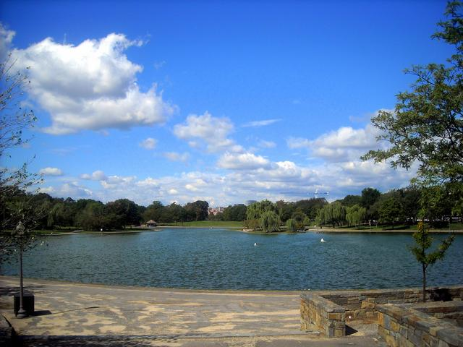

4. Constitution Gardens

Washington, DC Officially established in 1965, National Mall and Memorial Parks actually protects some of the older parkland in the National Park System. Areas within this premier park provide visitors with ample opportunities to commemorate presidential legacies; honor the courage and sacrifice of war veterans; and celebrate the United States commitment to freedom and equality. (Source: U S National Park Service)

Read more: [http://www.mycouponbuddy.com#ixzz4F0joGGJB](http://www.mycouponbuddy.com/#ixzz4F0joGGJB)

Inexpensive Vacations - District of Columbia Jun 17, 2016

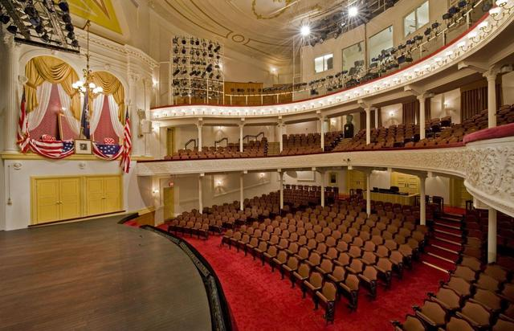

5. Ford's Theatre

Washington, DC Explore Ford's Theatre NHS, discover Abraham Lincoln's life in Washington, D.C., the struggle for a united country, and the motivation behind Lincoln's assassination. The National Park Service and the Ford's Theatre Society present a variety of programs year round. (Source: U S National Park Service)

Read more: [http://www.mycouponbuddy.com#ixzz4F0jqmMl6](http://www.mycouponbuddy.com/#ixzz4F0jqmMl6)

**Inexpensive Vacations - District of Columbia** Jun 17, 2016

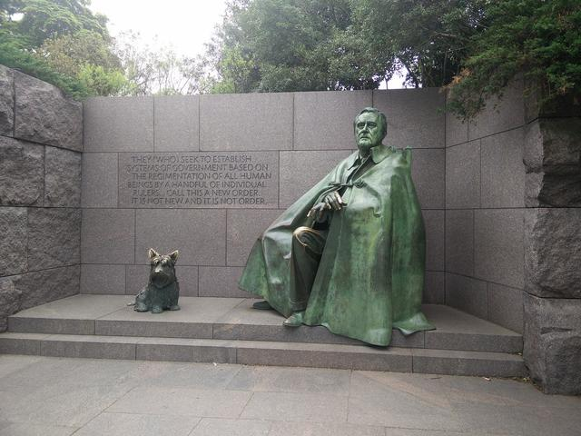

6. Franklin Delano Roosevelt Memorial

Washington, DC "The only thing we have to fear is fear itself...." iconic words from an iconic president. Learn more about the man, his memorial and his lasting legacy to the Nation. (Source: U S National Park Service)

[prev](http://slideshows.mycouponbuddy.com/s/inexpensive-vacations-district-columbia/5?utm_campaign=Slideshow60&utm_source=publisher19&source=si&utm_medium=cpa&pub=19&sid=079e936a-d8ae-4275-986e-9dfb58fa9a13)

[next](http://slideshows.mycouponbuddy.com/s/inexpensive-vacations-district-columbia/advertisement/6?utm_campaign=Slideshow60&utm_source=publisher19&source=si&utm_medium=cpa&pub=19&sid=079e936a-d8ae-4275-986e-9dfb58fa9a13)

[Legal](http://mycouponbuddy.com/en/legal)

Read more: [http://www.mycouponbuddy.com#ixzz4F0jsRnFO](http://www.mycouponbuddy.com/#ixzz4F0jsRnFO)

Inexpensive Vacations - District of Columbia Jun 17, 2016

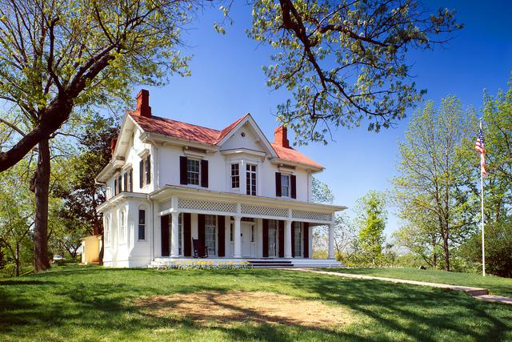

7. Frederick Douglass National Historic Site

Washington, DC Frederick Douglass spent his life fighting for justice and equality. Born into slavery in 1818, he escaped as a young man and became a leading voice in the abolitionist movement. Today, people everywhere still find inspiration in his tireless struggle, brilliant words, and inclusive vision of humanity. Douglass's legacy is preserved here at Cedar Hill, where he lived his last 17 years. (Source: U S National Park Service)

Read more: [http://www.mycouponbuddy.com#ixzz4F0jvM43Q](http://www.mycouponbuddy.com/#ixzz4F0jvM43Q)

Inexpensive Vacations - District of Columbia Jun 17, 2016



8. Kenilworth Park & Aquatic Gardens

Washington, DC In an age old dance wind, water, and land combine here. Sparkling in the sun on a breezy day, this natural area of Anacostia Park has origins in a 1926 act of Congress to preserve the forests, water quality, and recreation value of the waterways of Washington, DC. The park reflects the policies that affect rivers and wetlands. Come, join the dance. (Source: U S National Park Service)

Read more: [http://www.mycouponbuddy.com#ixzz4F0jxoZyP](http://www.mycouponbuddy.com/#ixzz4F0jxoZyP)

Inexpensive Vacations - District of Columbia Jun 17, 2016

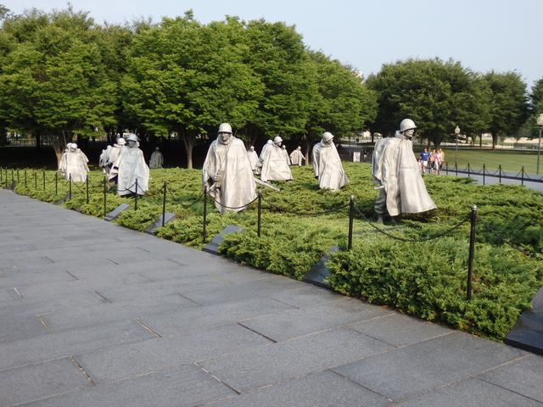

9. Korean War Veterans Memorial

Washington, DC Our nation honors her sons and daughters who answered the call to defend a country they never knew and a people they never met. (Source: U S National Park Service)

Read more: [http://www.mycouponbuddy.com#ixzz4F0jzmEiW](http://www.mycouponbuddy.com/#ixzz4F0jzmEiW)

Inexpensive Vacations - District of Columbia Jun 17, 2016

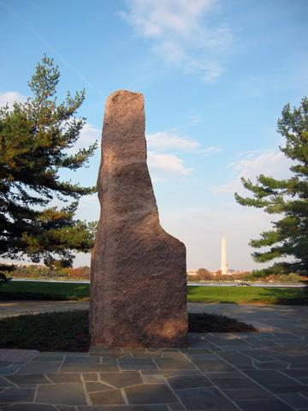

10. LBJ Memorial Grove on the Potomac

Washington, DC From this distance the seat of national power appears pristine across the river, so President Johnson came here often when he needed to escape from the stresses of building a Great Society. After he died, his wife chose this place for his memorial. A landscape of serpentine paths, white pines, a granite monolith, and an open meadow honors his legacy of social justice and conservation legislation. (Source: U S National Park Service)

Read more: [http://www.mycouponbuddy.com#ixzz4F0k2gR00](http://www.mycouponbuddy.com/#ixzz4F0k2gR00)

Inexpensive Vacations - District of Columbia Jun 17, 2016

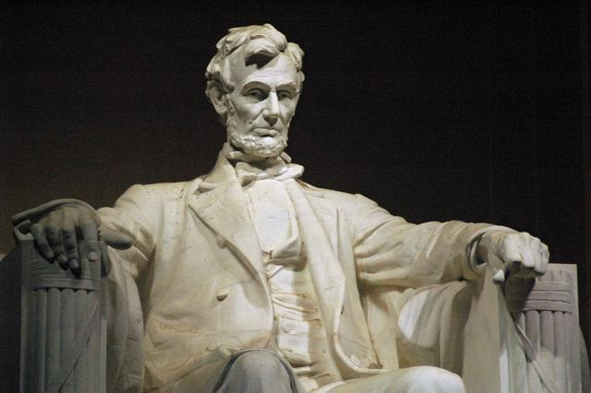

11. Lincoln Memorial

Washington, DC "In this temple, as in the hearts of the people for whom he saved the Union, the memory of Abraham Lincoln is enshrined forever." Beneath these words, the 16th President of the United States sits immortalized in marble as an enduring symbol of unity, strength, and wisdom. (Source: U S National Park Service)

Read more: [http://www.mycouponbuddy.com#ixzz4F0k4lJmM](http://www.mycouponbuddy.com/#ixzz4F0k4lJmM)

Inexpensive Vacations - District of Columbia Jun 17, 2016

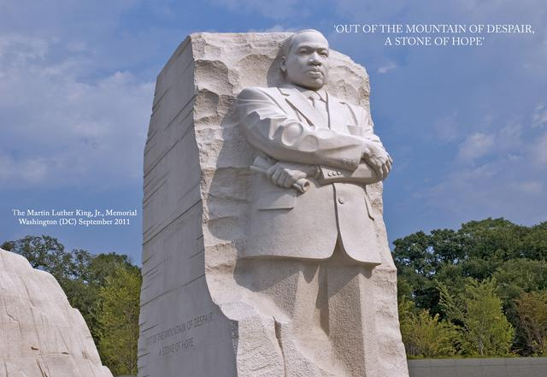

12. Martin Luther King, Jr. Memorial

Washington, DC Located in downtown Washington, D.C., the memorial honors Martin Luther King, Jr.'s legacy and the struggle for freedom, equality, and justice. (Source: U S National Park Service)

Read more: [http://www.mycouponbuddy.com#ixzz4F0k72FRr](http://www.mycouponbuddy.com/#ixzz4F0k72FRr)

Inexpensive Vacations - District of Columbia Jun 17, 2016

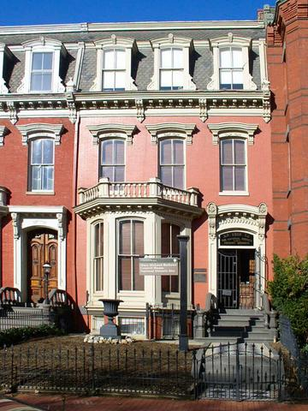

13. Mary McLeod Bethune Council House National Historic Site

Washington, DC Mary McLeod Bethune achieved her greatest recognition at the Washington, DC townhouse that is now this National Historic Site. The Council House was the first headquarters of the National Council of Negro Women (NCNW) and was Bethune’s last home in Washington, DC. From here, Bethune and the NCNW spearheaded strategies and developed programs that advanced the interests of African American women. (Source: U S National Park Service)

Read more: [http://www.mycouponbuddy.com#ixzz4F0kA9QCx](http://www.mycouponbuddy.com/#ixzz4F0kA9QCx)

Inexpensive Vacations - District of Columbia Jun 17, 2016

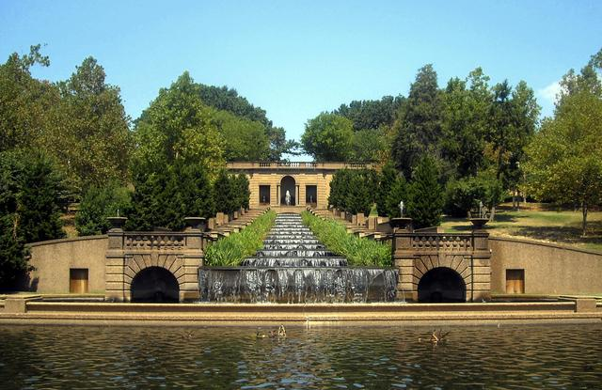

14. Meridian Hill Park

Washington, DC An administrative unit of Rock Creek Park, Meridian Hill Park is an urban park like no other. The formal, 12-acre site includes unique statues, the largest cascading fountain in North America, concrete aggregate architecture, a U.S. presidential memorial, and more. Designed based off of an Italian aristocrat's private residence, Meridian Hill Park is open to everyone. Come all, come one! (Source: U S National Park Service)

Read more: [http://www.mycouponbuddy.com#ixzz4F0kC7bX7](http://www.mycouponbuddy.com/#ixzz4F0kC7bX7)

Inexpensive Vacations - District of Columbia Jun 17, 2016

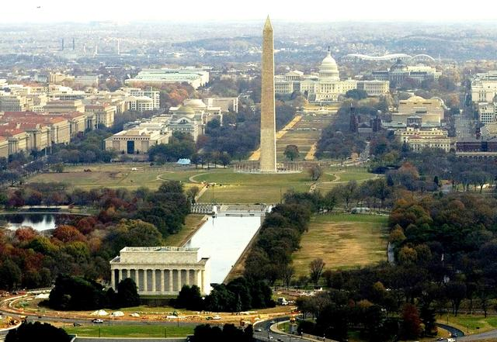

15. National Mall and Memorial Parks

Washington, DC Each year, millions of people visit the National Mall and Memorial Parks to recreate, to commemorate presidential legacies, to honor our nation's veterans, to make their voices heard, and to celebrate our nation's commitment to freedom and equality. (Source: U S National Park Service)

Read more: [http://www.mycouponbuddy.com#ixzz4F0kDzSjf](http://www.mycouponbuddy.com/#ixzz4F0kDzSjf)

Inexpensive Vacations - District of Columbia Jun 17, 2016

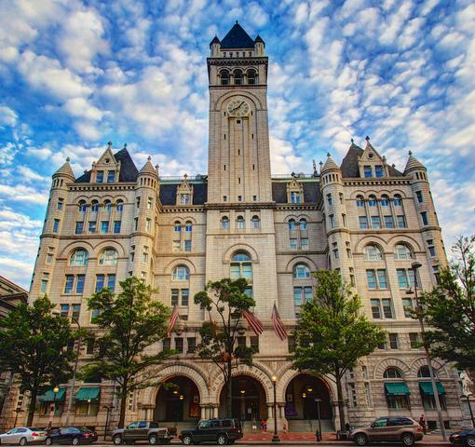

16. Old Post Office Tower

Washington, DC Built in 1899, the Old Post Office's clock tower offers panoramic views of Washington, D.C. The tower houses the Congress Bells, a Bicentennial gift from England commemorating friendship between the nations. The Tower is closed until 2016 as the entire building is currently undergoing major renovations. (Source: U S National Park Service)

Read more: [http://www.mycouponbuddy.com#ixzz4F0kGyWdF](http://www.mycouponbuddy.com/#ixzz4F0kGyWdF)

Inexpensive Vacations - District of Columbia Jun 17, 2016

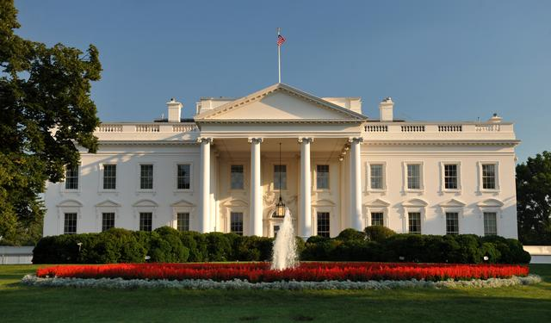

17. President's Park (White House)

Washington, DC Every president except George Washington has called the White House and its surrounding grounds his place of work, rest, and solitude. Recognizable around the world, the White House stands as a symbol of democracy. The White House and its park grounds serve not only as the seat of the executive branch of the government of the United States of America but also, as an iconic place for civil discourse. (Source: U S National Park Service)

Read more: [http://www.mycouponbuddy.com#ixzz4F0kIvPQy](http://www.mycouponbuddy.com/#ixzz4F0kIvPQy)

Inexpensive Vacations - District of Columbia Jun 17, 2016

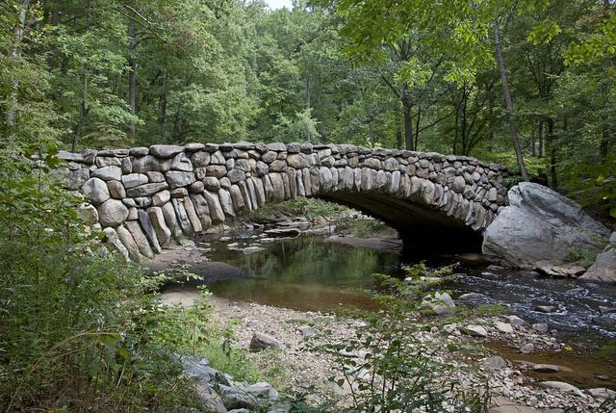

18. Rock Creek Park

Washington, DC Rock Creek Park is truly a gem in our nation's capital. It offers visitors opportunity to reflect and soothe their spirits through the beauty of nature. Fresh air, majestic trees, wild animals, and thousands of years of human history emanate the delicate aura of the forest. We invite you to Find Yourself in Rock Creek Park and help celebrate the Park Service's 100th birthday. (Source: U S National Park Service)

Read more: [http://www.mycouponbuddy.com#ixzz4F0kKz8h7](http://www.mycouponbuddy.com/#ixzz4F0kKz8h7)

Inexpensive Vacations - District of Columbia Jun 17, 2016

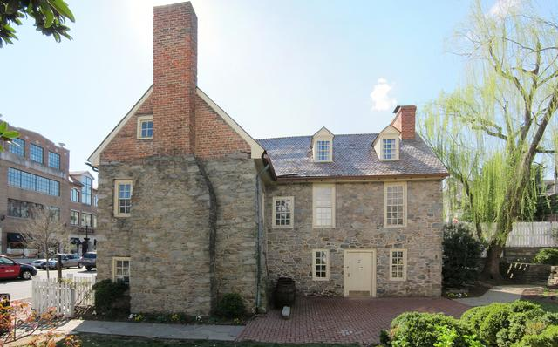

19. The Old Stone House

Washington, DC As the nation's capital, Washington, DC is known primarily as a city of grand memorials to national leaders and significant events. But aren't the lives of DC's "regular" citizens and "regular" buildings significant too? The oldest building in DC, Old Stone House commemorates the daily lives of Georgetown's early residents. The house serves as a great example of Revolutionary War-era architecture. (Source: U S National Park Service)

Read more: [http://www.mycouponbuddy.com#ixzz4F0kNicRW](http://www.mycouponbuddy.com/#ixzz4F0kNicRW)

Inexpensive Vacations - District of Columbia Jun 17, 2016

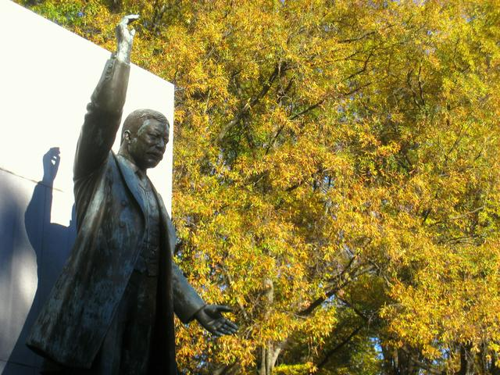

20. Theodore Roosevelt Island

Washington, DC In the 1930s landscape architects transformed Mason’s Island from neglected, overgrown farmland into Theodore Roosevelt Island, a memorial to America’s 26th president. They conceived a “real forest” designed to mimic the natural forest that once covered the island. Today miles of trails through wooded uplands and swampy bottomlands honor the legacy of a great outdoorsman and conservationist (Source: U S National Park Service)

Read more: [http://www.mycouponbuddy.com#ixzz4F0kQMAH9](http://www.mycouponbuddy.com/#ixzz4F0kQMAH9)

Inexpensive Vacations - District of Columbia Jun 17, 2016

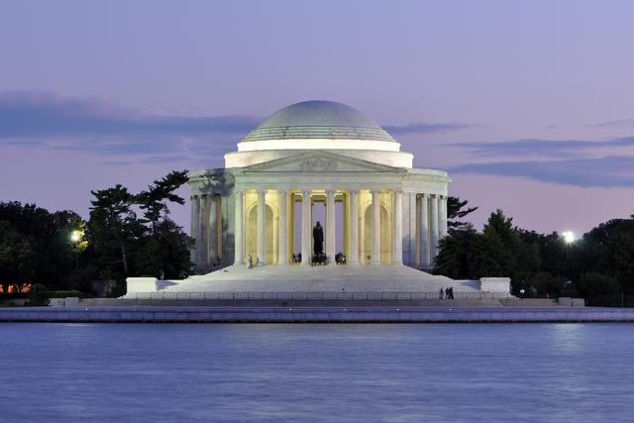

21. Thomas Jefferson Memorial

Washington, DC Author of the Declaration of Independence, Statesman and Visionary for the founding of a Nation. In its setting by the Tidal Basin, the Jefferson Memorial is especially beautiful when surrounded by the cherry blossoms in the Spring. (Source: U S National Park Service)

Read more: [http://www.mycouponbuddy.com#ixzz4F0kSIK00](http://www.mycouponbuddy.com/#ixzz4F0kSIK00)

Inexpensive Vacations - District of Columbia Jun 17, 2016

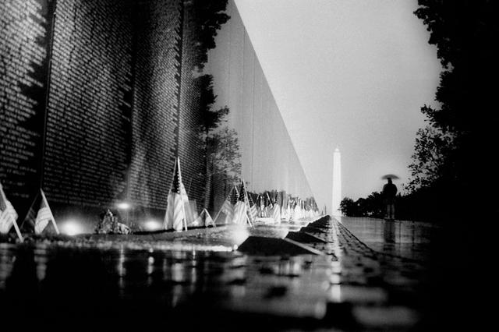

22. Vietnam Veterans Memorial

Washington, DC Honoring the men and women who served in the controversial Vietnam War, the Vietnam Veterans Memorial chronologically lists the names of more than 58,000 Americans who gave their lives in service to their country. (Source: U S National Park Service)

Read more: [http://www.mycouponbuddy.com#ixzz4F0kV9P6U](http://www.mycouponbuddy.com/#ixzz4F0kV9P6U)

Inexpensive Vacations - District of Columbia Jun 17, 2016

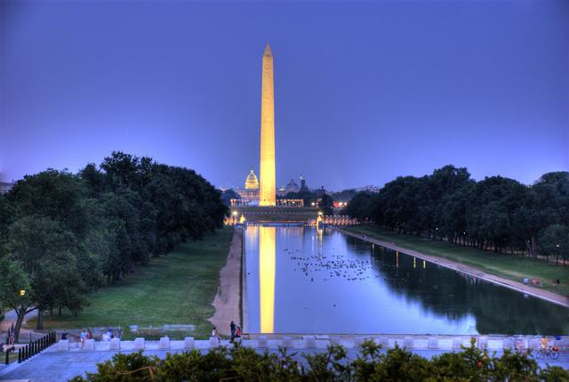

23. Washington Monument

Washington, DC Built to honor George Washington, the United States' first president, the 555-foot marble obelisk towers over Washington, D.C. Tickets are required to visit the interior of the Washington Monument. (Source: U S National Park Service)

Read more: [http://www.mycouponbuddy.com#ixzz4F0kXG71D](http://www.mycouponbuddy.com/#ixzz4F0kXG71D)

Inexpensive Vacations - District of Columbia Jun 17, 2016

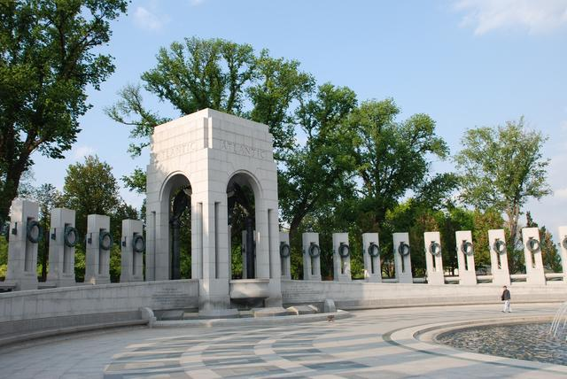

24. World War II Memorial

Washington, DC Through stone architecture and bronze sculptures, the World War II Memorial recognizes the ways Americans served, honors those who fell, and recognizes the victory they achieved to restore freedom and end tyranny around the globe. (Source: U S National Park Service)

Read more: [http://www.mycouponbuddy.com#ixzz4F0kZQvOc](http://www.mycouponbuddy.com/#ixzz4F0kZQvOc)

Inexpensive Vacations - District of Columbia Jun 17, 2016

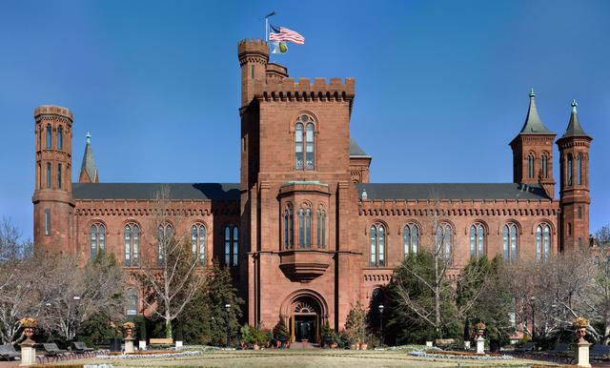

25. The Smithsonian Institute

The Smithsonian Castle sits on the National Mall surrounded by the many museums featuring American History, Air & Space, Art, Museums and the Sculpture Garden, as well as, museums dedicated to Natural History and some of the many cultures that call the United States home.

Read more: [http://www.mycouponbuddy.com#ixzz4F0kcWJTL](http://www.mycouponbuddy.com/#ixzz4F0kcWJTL)